2019

School Name: School of Computing Semester: AY1920 Semester 2 Course Name: DIT Module Code: ST1502 Module Name: Data Visualization

7/16/2019

DAVI Assignment 1 (CA1)

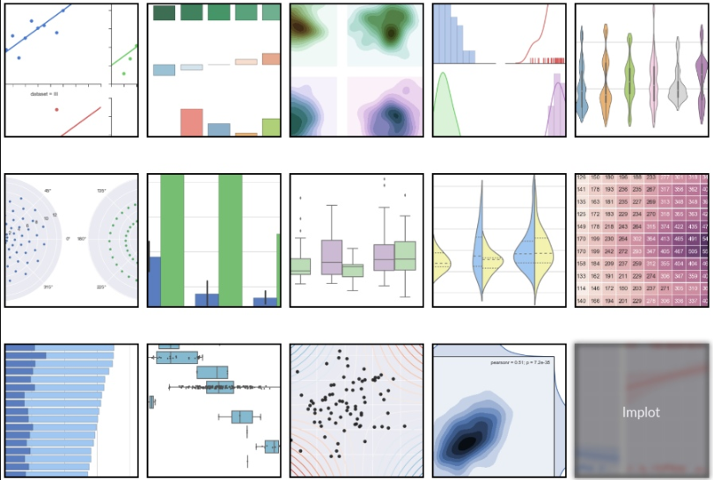

Section 1.1 Group: Instructions and Guidelines 2

Section 1.2 Group: Scope of the assignment 3

Basic Requirements 3

Section 1.3 Group: Marking Scheme 4

Section 2.1 Ind: Instructions and Guidelines 5

Section 2.2 Ind: Scope of the assignment 6

Basic Requirements 6

Section 2.3 Ind: Marking Scheme 8

# Section 1.1 Group: Instructions and Guidelines

1. There are 2 parts to this assignment; group work (40 marks) and individual work (60 marks). For group work, you are to work in a group of 3 or 4 members. Assume that you are a group of consultants who work on a topic to analyse the existing data, gather insights and suggest recommendations that could help Singpaore or the world to make improvements.
2. The requirements of this group assignment are outlined in Section 1.2 of this document.
3. Submissions should be made via the Blackboard by the stated deadline
   1. Group work: CA1 Group Assignment Submission link
   2. Deliverable should be a zip file with the following file-naming convention, “Project Leader Name.zip”
4. For group work, submit a Zip file that include a set of Powerpoint slides that summarizes the data insights that you have gained.
5. CA1 assignment (group and individual) acounts for **30%** of the **module grade**.
6. No marks will be awarded, if the work is copied or you have allowed others to copy your work.
7. 50% of the marks will be deducted for assignments that are received within ONE (1) calendar day after the submission deadline. No marks will be given thereafter. Exceptions to this policy will be given to students with valid LOA on medical or compassionate grounds. Students in such cases will need to inform the lecturer as soon as reasonably possible.

# Section 1.2 Group: Scope of the assignment

Basic Requirements

In 2020 the world will generate huge amount of data. Within these data are huge opportunities for human advancement. To be able to turn opportunities into reality, people need the power of data at their fingertips. Your group of 3 or 4 members who are also consultants will identify a topic to work on. You may consider one of these topics such as environment, education, health, society or etc. You will retrieve relevant public data sets, generate relevant charts using Tableau software and analyse the data insights. You may wish to provide some suggestions or recommendations on how the data insights benefit the relevant authority.

For data sets, you may access to following URLs:

<https://www.tableau.com/learn/articles/free-public-data-sets>

<https://data.gov.sg/> and others

1. Select a topic to work on. State at least two objectives of the data analysis on the selected topic. For example, if the objective is to compare public transport daily ridership in Singapore. Then you will need to access to public transport daily ridership data set. Explain the datasets eg the data fields and description of the data.
2. Retrieve the relevant public datasets that is related to the topic of interest. Next, generate at least 2 dashboards. Explain the insights. More marks will be allocated if you are able to explain interesting insights using facts and figures.
3. Provide a summary of the data insights. Suggest at least 2 reocmmendations or 2 areas for improvement that are useful for the relevant authority to improve its operational efficiency or become a more efficeint and effective authority.
4. Your powerpoint slides should include the following:

* A cover page that lists group member IDs and names
* State the topic of interest and state the objectives of the data analysis.
* Explain the datasets. Example the number of data fields and types of data fields, the size of dataset and desctiption of the dataset.
* List the URLs and references of all the datasets and materials you have used
* For each dashboard, you may wish to provide some conclusions or recommendations.

1. Zip file should include the following items:

* A set of Powerpoint slides that summarizes the data insights that you have gained.
* A twbx file (a Tableau Storyboard)
* Include data sets

1. Your group will need to give a short presentation to your tutor during lesson time. Every member will need to present. Your module tutor may ask you questions about the charts you have generated during this interview / presentation session. The total number of powerpoint slides is about 6. Each group is allocated 10 mins for presention cum demonstration.

# Section 1.3 Group: Marking Scheme

Marks will be awarded to each student based on the following rubrics.

To score higher marks, you are encouraged to explore and experiment beyond the syllabus and demonstrate your independently-acquired skills via your deliverables / interview.

|  |  |
| --- | --- |
| A: Group Work - Component | Weightage |
| Assignment requirements are met  State at least two objectives of analysing the data for the selected topic.  Explain the datasets. | 10% |
| Generate at least 2 dashboards. One dashboard may have 3 charts. Explain the data insights. | 15% |
| Provide a summary of the data insights. Suggest at least 2 reocmmendations or 2 areas for improvement that are useful for the relevant authority to improve its operational efficiency or become a more efficeint and effective authority. | 10% |
| Quality of data insights and presentation slides | 5% |

# Section 2.1 Ind: Instructions and Guidelines

* 1. This is an **INDIVIDUAL** assignment which requires the student to use Tableau software to generate relevant charts. Students are required to retrieve the given data set, “appstore_games.csv”. You may cleanse the data (optional) and visualize the data using Tableau software.
  2. The requirements of this assignment are outlined in Section 2.2 of this document.
  3. Submissions should be made via the Blackboard CA1 Assignment Submission link by the stated deadline.
  4. Deliverable should be a zip file with the following file-naming convention “**YourStudentID-YourName.zip”**
  5. Zip file should include the following items:
* A set of Powerpoint slides that summarizes the data insights that you have gained.
* A twbx file (a Tableau Story Board)
* A self-reflection document that briefly states the challenges you have faced and the take-aways you have gained from doing this assignment

6.

CA1 assignment (Group and Individual) accounts for **30%** of the **module grade**.

1. No marks will be awarded, if the work is copied or you have allowed others to copy your work.
2. 50% of the marks will be deducted for assignments that are received within ONE (1) calendar day after the submission deadline. No marks will be given thereafter. Exceptions to this policy will be given to students with valid LOA on medical or compassionate grounds. Students in such cases will need to inform the lecturer as soon as reasonably possible. Students are not to assume on their own that their deadline has been extended.

# Section 2.2 Ind: Scope of the assignment

In this individual assignment, you are required to use Tableau software to generates charts and to gather insights from the data. You are required to present the data insights and conclude your findings.

Basic Requirements

1. You are required to use at least one dataset. You may access to [www.kaggle.com](http://www.kaggle.com) or <https://data.gov.sg> or etc You may merge the datasets. You are required to demonstrate your ability to create data dashboards by following the guidelines below:
2. Each student is required to use Tableau to create a “Story” which should consist of at least **2 dashboards.** **Each dashboard may have 3 or 4 charts**. You are to showcase your ability in the following:

* Interactivity of visuals
* Variety of visuals
* Usefullness of visuals
* Sensibility of visuals

1. Your submission should contain at least 4 different types charts:

* One line chart
* One bar chart or histogram chart
* One box-whisker chart
* One scatter plot
* One KPIs and parameter control chart
* One calculated field chart

You will submit your datasets and a .twbx file

1. Your dashboards should help you to gain deeper insights into the given dataset such that you are able to craft a ‘storyline’ or produce an interesting data analysis on it.

Compile your findings into a Tableau storyboard.

Your Powerpoint slides should include the following sections:

* A cover page that lists your name and the title of your data analysis
* A slide that lists the URLs of all the datasets you have used
* For each dataset, one slide or more to briefly explain the **nature of that dataset** (i.e. what is in that dataset) or any pecularities about it you wish to highlight
* For each dataset, one slide or more to explain the **process** you went through to merage and analyse that dataset. Where possible, you should specifically mention how you used the data visualization library functions to achieve a certain outcome e.g. to transform the data or to produce a certain visualization
* For each dataset, the **insights** you have gained from analysing the data and any conclusions or recommendations you want to make as a result of the analysis

1. You may reflect on your **challenges** and your **achievements** in completing this assignment and document it using the given “Reflection for CA1” template.
2. Summary of submission for CA1: individual work. Submit a zip file with all the following. The file naming convention is **“YourStudentID-YourName.zip”**
3. Datasets
4. A file with .twbx format
5. A set of powerpoint slides
6. A “Reflection for CA1” template

# Section 2.3 Ind: Marking Scheme

Marks will be awarded to each student based on the following rubrics.

To score higher marks, you are encouraged to explore and experiment beyond the syllabus and demonstrate your independently-acquired skills via your deliverables / interview.

|  |  |
| --- | --- |
| Component | Weightage |
| Assignment requirements are met   * Use the given data set and generate relevant charts using Tableau software. * A deck of Powerpoint slides that explain the datasets, summarizes the insights gained from the analysis of the data and provide conclusions or recommendations. | 10% |
| Quality of application   * Technical complexity * Code quality * User-friendliness * Aesthetics * Creativity | 20% |
| Data analysis   * Completeness in the analysis of data (more marks will be awarded for coherence explanation of the various charts) * Quality of analysis and presentation | 20% |
| Self-reflection   * Explaination of challenges faced * Explaination of achievements made * State all library resources you refer to for CA1. | 10% |

**-- End of Assignment Specifications --**